Chapter I
INTRODUCTION

Background of the Study
Information technology helps government offices deliver faster, more organized, and dependable public services. In the Philippines, the barangay serves as the primary political and administrative unit where citizens directly interact with government services, as stated in Republic Act No. 7160, also known as the Local Government Code of 1991. Barangays are responsible for keeping track of local residents, maintaining peace and order, issuing certifications, settling neighborhood disputes, and providing immediate community relief during emergencies. Because of these essential responsibilities, having a fast and reliable record-keeping system is necessary for every barangay hall.
Barangay Dacutan is one of the coastal and agricultural barangays situated in the Municipality of Dumangas, Province of Iloilo, under Region VI (Western Visayas). The community is divided into seven puroks and two sitios, namely Purok 1 to Purok 7, Sitio Ilawod, and Sitio Ilaya. The barangay hall serves as the main center for local administration, where residents frequently go to request barangay clearances, certificates of indigency, certificates of residency, and business permits. The barangay is also actively involved in settling community disagreements through the Katarungang Pambarangay council and managing calamity assistance programs like typhoon relief food packs and government cash aid.
Currently, Barangay Dacutan still depends heavily on manual and paper-based methods for managing its everyday records. When a resident comes to the barangay hall to ask for a clearance or certificate, the staff must manually search through paper logbooks, binders, or index cards to confirm the resident's name, purok, and records. Once verified, the Barangay Secretary types or fills out a paper template, collects the corresponding fee, writes a manual paper receipt, and brings the document to the Punong Barangay for an ink signature. For blotter disputes, complaints are written by hand into a physical blotter book, and hearing schedules are kept on loose desk calendars. Likewise, during disaster relief distributions, lists of beneficiaries from special sectors like senior citizens, persons with disabilities (PWDs), and 4Ps members are written on paper sheets.
This traditional manual process causes several major problems for both the barangay personnel and the citizens. First, physical record books are prone to tear, water damage, ink fading, and insect damage over time. Second, searching for a single record among stacked boxes takes too much time, especially when verifying whether an individual has a pending dispute in the blotter records before issuing a clearance. Third, citizens often have to make repeated visits to the barangay hall just to inquire if their requested document has already been signed, leading to long waiting lines and frustration. Lastly, during emergency relief operations, having no centralized digital database makes it hard to quickly verify who is truly qualified, resulting in slow distribution and risks of duplicate food packs.
To solve these problems, the researchers proposed and developed the Barangay Information and Management System (BIMS) for Barangay Dacutan, Dumangas, Iloilo. The system is a web-based application designed to modernize and organize barangay operations. It features three specific user roles: the Resident (general public), the Punong Barangay (Barangay Captain), and the Barangay Secretary (who also handles general routine clerical paperwork). The system provides a citizen public landing portal where residents can directly apply for twelve (12) different certificates and documents across personal, business, and dispute categories, and track the real-time status of their requests using an automated reference number. For barangay officials and staff, it provides a secured administrative portal with modules for census resident profiling with purok mapping, automated clearance issuance with authentic Philippine Republic standard A4 printable layouts, Katarungang Pambarangay blotter dispute mediation tracking, and emergency calamity aid distribution monitoring. To eliminate the administrative headache of managing citizen user accounts and forgotten passwords while safeguarding the system against spam and malicious bot entries, the system adopts the recommended compromise of One-Time Pin (OTP) Verification via SMS or Email. When a resident completes the online document request and appointment form, the system dispatches a transient 4-digit code to their active mobile phone or email. Entering this code verifies that the requestor is a genuine individual with an active contact number, eliminating fake submissions without forcing residents to register and manage password-protected accounts.
By implementing this computerized system, Barangay Dacutan can significantly improve its public service efficiency. Document processing time will be reduced from hours or days to just a few minutes. Citizen records will be safely preserved inside a secure MySQL database, preventing data loss. In addition, the system will support local transparency, help staff quickly identify vulnerable households needing immediate aid, and uphold the standard of modern, responsive e-governance in the community.

Objectives of the Study
The main objective of the study was to develop, implement, and evaluate the web-based Barangay Information and Management System (BIMS) for Barangay Dacutan, Municipality of Dumangas, Province of Iloilo.
Specifically, the study aimed to:
• design and create a centralized relational database to safely store resident census profiles, official clearances, dispute cases, and aid distribution records;
• manage secure administrative user accounts for authorized barangay officials and enforce a two-tier review and approval workflow where citizen document requests are evaluated by the Barangay Secretary (acting as administrative records officer) and granted final executive approval by the Punong Barangay;
• provide a public citizen portal where community residents can view barangay information, schedule document appointments, and apply online for twelve (12) official certificates and documents across personal, business, and dispute categories, secured through an One-Time Pin (OTP) verification mechanism via SMS or Email that transmits a 4-digit code to validate active contact numbers and eliminate fake/spam entries without requiring password-based account registration, receive automated email status notifications upon secretary review and captain approval, and track request progress in real time using a unique reference code;
• record and monitor resident census records with complete demographic details, purok classifications, and special sector eligibility flags such as Senior Citizens, PWDs, 4Ps members, and registered voters;
• generate and print official Philippine Republic standard A4 barangay clearances, permits, and certifications complete with dual municipal and barangay seals, council roster sidebars, thumbmark boxes, and official receipt information;
• record and monitor Katarungang Pambarangay blotter disputes, hearing schedules, and amicable settlement terms under the Lupon Tagapamayapa, including the issuance of Blotter Certifications and Certifications to File Action; and
• evaluate the developed system using the ISO 25010 software quality.

Conceptual Framework of the Study
The conceptual framework of this study was developed using the Input-Process-Output (IPO) model, integrated with an evaluation feedback loop. Figure 1 shows the conceptual framework of this study.
Input
- User Information
- Resident Information
- Document Request Information

- Blotter Incident Information
- Calamity Aid Information
Output

Barangay Information and Management System
(Brgy. Dacutan, Dumangas, Iloilo)
Process
- Manage user accounts
- Register and manage residents

- Process document requests

- Manage blotter and dispute records

- Record aid distribution

- Generate system reports
System Evaluation ( ISO 25010 )

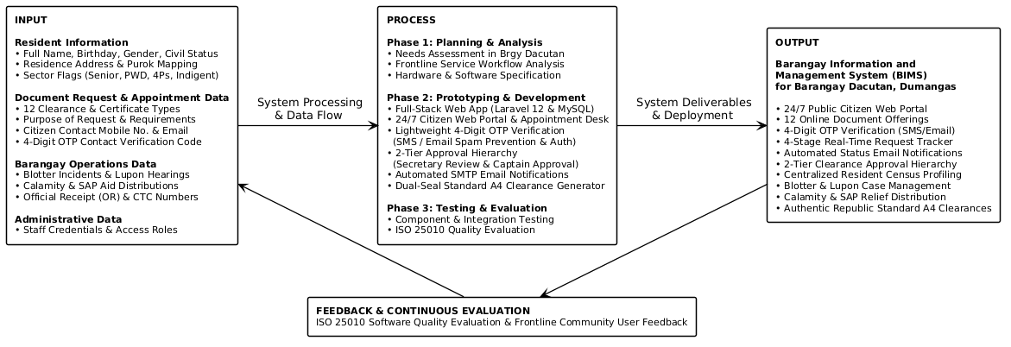
Figure 1. Conceptual Framework of the Study (IPO Model)

The input stage consists of the essential data and information required by the system, including administrative user information, resident census information, document request and appointment information (including citizen contact numbers and 4-digit OTP verification codes), blotter incident information, and calamity aid information. These inputs serve as the foundation for the system's operations and ensure that all processes are based on complete and accurate community data.

The process stage involves the core activities needed to transform the inputs into the desired system outputs. These include managing administrative user accounts, authenticating citizen appointment requests through 4-digit OTP verification via SMS or email to prevent spam without password registration, registering and managing resident records, processing document requests through a two-tier clerical review and executive approval hierarchy, managing blotter and dispute records, recording calamity aid distribution, and generating system reports. These processes are designed to ensure that the system operates efficiently, provides reliable records, and speeds up daily administrative tasks at the barangay hall.

The output of the framework is the Barangay Information and Management System, a functional web-based system that modernizes public service delivery in Barangay Dacutan. To ensure the system’s quality and dependability, the framework includes a system evaluation phase, where the developed system is assessed using the ISO/IEC 25010 software quality model across functional suitability, performance efficiency, compatibility, usability, reliability, security, maintainability, and portability. The results of the evaluation serve as feedback, guiding further improvements by refining inputs and processes to better serve the community.

Definition of Terms
To provide clear understanding, the key terms used in this study are conceptually and operationally defined as follows:
Aid Distribution (Ayuda). The systematic allocation and handover of relief goods, cash assistance, or emergency supplies to affected families during calamities or social welfare programs (Flores et al., 2023). In this study, aid distribution refers to the administrative module used to log relief packages, cash subsidies, and food packs given to verified residents of Barangay Dacutan, with special tracking for seniors, PWDs, 4Ps, and indigent households.
Barangay Clearance. An official legal document issued by the barangay certifying that an individual is a official resident of the community and possesses good moral character with no derogatory criminal record (Brillantes & Perante-Calina, 2018). In this study, barangay clearance refers to the printable official certification generated by the system using standard Philippine Republic A4 layout, featuring dual municipal and barangay seals, official receipt numbers, and valid signatures.
Barangay Secretary. An appointed local government officer responsible for maintaining official records, preparing minutes of council sessions, and managing administrative correspondence in the barangay (Republic of the Philippines, 1991). In this study, the Barangay Secretary refers to the primary administrative user role who also performs routine clerical duties, evaluates incoming online document requests, manages resident records, schedules Lupon hearings, and prepares clearances.
Blotter Record. A formal written log maintained by peacekeepers and community officials that documents daily complaints, disputes, incidents, and mediation proceedings (Pe & Tadiar, 2017). In this study, blotter record refers to the computerized database module where complainant and respondent information, incident details, hearing dates, and Lupon Tagapamayapa amicable settlements are stored and tracked.
Certification to File Action (CFA). A formal attestation issued by the Lupon Tagapamayapa certifying that dispute conciliation before the barangay failed, allowing the dispute to be formally filed in a court of law (Pe & Tadiar, 2017). In this study, Certification to File Action refers to the legal record generated by the system under the Katarungang Pambarangay module when mediation between disputing residents does not reach an agreement.
Database Management System (DBMS). A collection of software programs that enables users to create, maintain, query, and modify electronic databases while enforcing data security and relational integrity (Coronel & Morris, 2020). In this study, DBMS refers to MySQL 8.0, which stores all resident demographic profiles, issued certificates, user accounts, and blotter records on the secure live cloud web server.
ISO 25010. An internationally recognized standard that defines a software product quality model categorized into eight characteristics to measure software effectiveness and user satisfaction (International Organization for Standardization, 2011). In this study, ISO 25010 refers to the evaluation questionnaire and rating framework used by IT experts and barangay officials to grade the system from 1 to 5.
Katarungang Pambarangay. The local community-level justice and mediation system in the Philippines established to peacefully settle neighborhood disputes without immediately filing court cases (Pe & Tadiar, 2017). In this study, Katarungang Pambarangay refers to the dispute management section of the system that tracks mediation stages from initial filing to amicable resolution or court referral.
Laravel. An open-source PHP web framework that utilizes the Model-View-Controller (MVC) architectural pattern to build secure, scalable, and modular web applications (Otwell, 2024). In this study, Laravel refers to the PHP backend engine powering the business logic, route security, and database controllers of BIMS.
Purok. A sub-division or neighborhood cluster within a Philippine barangay that groups residential households for administrative and census purposes (Brillantes & Perante-Calina, 2018). In this study, purok refers to the territorial groupings in Barangay Dacutan, specifically Purok 1 through Purok 7, Sitio Ilawod, and Sitio Ilaya, used for filtering resident records and demographic charts.
Resident Profiling. The process of recording and organizing individual citizen demographics, socioeconomic standing, and household data for planning and social service allocation (Santos et al., 2021). In this study, resident profiling refers to the computerized masterlist module containing resident names, birthdates, purok addresses, contact numbers, voter registration, and sector classifications.

Significance of the Study
The results and output of this study will be directly beneficial to the following groups of individuals and institutions:
Punong Barangay (Barangay Captain). The system provides the barangay captain with an executive dashboard showing real-time demographic statistics, monthly revenue collection totals, pending dispute rates, and active citizen applications. This helps leadership make informed, timely decisions and plan local projects with accurate population data.
Barangay Secretary (and Clerical Staff). The system significantly lessens the daily administrative and clerical workload of the secretary. Instead of manually searching through physical logbooks and index cards, the secretary can verify resident records in seconds, process online clearance requests across 12 document categories, record official receipts, and monitor mediation schedules with automated tracking numbers. In addition, because the system employs lightweight 4-digit OTP verification on appointment requests rather than mandatory citizen account registration, the secretary is completely relieved from the administrative burden of managing citizen login accounts, handling forgotten password requests, and cleaning up spam submissions.
Residents of Barangay Dacutan. Community members save substantial time and travel expenses by accesscribing the public portal directly from their home computers or smartphones. They can request any of the 12 offered personal, business, or dispute documents and monitor application status in real time without making repeated trips to the barangay hall. Furthermore, residents enjoy a frictionless requesting experience without having to create or remember account passwords, verifying their identity easily through a 4-digit OTP sent to their mobile phone or email.
Municipality of Dumangas and DILG. The project promotes compliance with national e-governance and ease of doing business standards (Republic Act 11032). It gives local municipal authorities an practical example of digitalized community governance.
Iloilo Science and Technology University - Dumangas Campus (ISAT U - DC). This study showcases the university's mission of applying technology to address real-world community needs. It proves that students of ISAT U - Dumangas Campus can create practical and functioning information systems that directly serve local barangays.
Future Researchers. This manuscript and system can serve as a dependable reference, baseline guide, and source of literature for upcoming IT students who plan to develop similar local governance, inventory, or community profiling systems.

Scope and Limitations of the Study
This study focuses on the development of the Barangay Information and Management System (BIMS) for Barangay Dacutan, Municipality of Dumangas, Province of Iloilo, designed to improve the efficiency, transparency, and delivery of community records management and frontline public services. The system is intended for use within the administrative jurisdiction of Barangay Dacutan, specifically covering all residential households situated across Purok 1 through Purok 7, Sitio Ilawod, and Sitio Ilaya.
The system includes an Executive Dashboard that serves as the central administrative hub for the Punong Barangay and authorized staff, providing real-time demographic indicators, revenue collection summaries, and active transaction queues. This ensures proper administrative control, data visibility, and informed community decision-making.
A Secretary and Clerical Records Interface is also included, allowing the Barangay Secretary and administrative staff to efficiently encode, verify, update, and manage resident census profiles, track community disputes under the Katarungang Pambarangay, and maintain calamity relief assistance distributions. This eliminates manual logbook searches, reduces paperwork, minimizes clerical recording errors, and speeds up the daily processing of community requests.
For community members, a Public Citizen Portal is available, providing secure and convenient access to official barangay announcements, leadership directories, and online applications for twelve (12) official certificates and documents across personal, business, and dispute categories. To prevent spam, prank submissions, and malicious bot entries without imposing the friction of mandatory account registration, the portal incorporates a lightweight 4-digit One-Time Pin (OTP) verification mechanism via SMS or Email that validates the applicant's active contact number prior to official submission. The portal also features a live four-stage document tracker, allowing citizens to monitor their application progress in real time using a unique tracking reference code without having to make repeated physical visits to the barangay hall.
The system also integrates a structured Two-Tier Approval Hierarchy supported by automated Email Notification Services. Under this workflow, incoming citizen applications are first reviewed and evaluated by the Barangay Secretary against the resident database, followed by final executive approval from the Punong Barangay before official clearances are printed using authentic Philippine Republic standard A4 layouts with municipal and barangay seals. Automated email notifications are dispatched directly to the citizen's email address at each step of the process, notifying residents when their application has been evaluated, approved, and prepared for release at the barangay hall.
To ensure accessibility and usability, the system is deployed on a live web hosting environment and accessed online via the internet through standard web browsers on smartphones, tablets, laptops, and desktop computers. This enables community residents to access the public citizen portal and submit document requests online 24/7 from anywhere without having to travel to the barangay hall during the initial application stage. To protect database integrity while keeping citizen services frictionless, password-based user accounts are strictly restricted to authorized administrative personnel (Punong Barangay and Barangay Secretary), whereas citizen requestors authenticate their appointments on demand via 4-digit OTP.
This study has several limitations that mean the study focuses strictly on its primary objective: modernizing resident records management, document issuance, and frontline community services in Barangay Dacutan.
The system is limited to web-based access and does not include a native downloadable mobile application. Users must access the system through modern desktop or mobile web browsers. Cellular SMS messaging is specifically focused on sending short, transient 4-digit OTP verification codes to validate applicant contact numbers upon submission, while general status milestone updates and clearance pickup notices are dispatched via automated SMTP email notifications and the public online tracking portal to minimize ongoing SMS gateway overhead. The system does not include an online electronic payment gateway, such as GCash or Maya, so all document fees are collected personally in cash at the barangay hall upon claiming, recorded with manual Official Receipt and Community Tax Certificate numbers. Furthermore, the application is strictly designed for the administrative jurisdiction and demographic records of Barangay Dacutan, Dumangas, Iloilo, and does not automatically integrate with external municipal or national police law enforcement databases.
The system does not include an online electronic payment gateway, such as GCash or Maya, so all document fees are collected personally in cash at the barangay hall upon claiming, recorded with manual Official Receipt and Community Tax Certificate numbers.
In addition, the application is strictly designed for the administrative jurisdiction and demographic records of Barangay Dacutan, Dumangas, Iloilo, and does not automatically integrate with external municipal or national police law enforcement databases.
Additionally, because the system is hosted live on the web, it depends on active internet connectivity and web hosting server uptime. Any internet service interruptions, network downtime, or hosting server maintenance may temporarily affect online system accessibility. By maintaining these limitations, the study ensures that the system remains focused, efficient, secure, and aligned with its primary goal of improving local governance, records organization, and public service delivery within Barangay Dacutan.

Chapter II
REVIEW OF RELATED LITERATURE AND STUDIES
This chapter presents a review of relevant literature, conceptual theories, and similar local and international studies that serve as the foundation of the proposed Barangay Information and Management System.

Related Literature

E-Governance and Local Government Automation
Brillantes and Perante-Calina (2018) emphasized that electronic governance (e-governance) in the Philippines is an essential tool in transforming public administration from slow, bureaucratic red tape into transparent, responsive, and accountable public service. They explained that automating basic government processes at the community level reduces human error, prevents loss of government records, and increases citizen trust in local institutions. In the context of local government units (LGUs), computerization allows barangay officials to manage community census records accurately and deliver timely services to their constituents.
This literature strongly supports the development of BIMS for Barangay Dacutan, showing that replacing manual paper records with an automated web portal directly promotes good local governance and faster community assistance.
Legal Mandates for Barangay Automation and Citizen Service Delivery
The legal framework governing local public administration in the Philippines mandates efficiency, transparency, and accessible public service. Republic Act No. 7160, known as the Local Government Code of 1991, designates the barangay as the primary unit of government responsible for delivering frontline services, keeping official census registries, and resolving community disputes through peaceful conciliation. To accelerate government responsiveness, Republic Act No. 11032, also known as the Ease of Doing
Business and Efficient Government Service Delivery Act of 2018, directs all government offices and local government units to re-engineer manual workflows, adopt electronic systems, eliminate unnecessary processing steps, and enforce strict turnaround deadlines for document issuance. In addition, Republic Act No. 11261, or the First Time Jobseekers Assistance Act of 2019, mandates barangays to issue certifications for first-time jobseekers free of charge to help youth secure employment requirements. To ensure that sensitive resident demographics, indigent profiles, and dispute records remain protected against unauthorized exposure, Republic Act No. 10173, the Data Privacy Act of 2012, imposes strict requirements for secure data storage and role-based access control.
These legal mandates directly justify the design of BIMS, which incorporates a public request portal for 12 document categories (including first-time jobseeker waivers under RA 11261), automated processing workflows compliant with RA 11032 turnaround targets, and role-based data security aligned with RA 10173.

Relational Database Management Systems in Community Records
Coronel and Morris (2020) explained that database systems are the backbone of modern record-keeping operations. A well-structured Relational Database Management System (RDBMS) organizes complex data into structured tables with defined primary and foreign keys. This design ensures data consistency, avoids duplicate entries, speeds up search queries, and guarantees data integrity even when dealing with thousands of resident records.
This literature supports the choice of MySQL 8.0 in this study, confirming that using a relational database ensures the demographic data, clearances, and blotter records of Barangay Dacutan remain secure, easily searchable, and free from duplication.

Katarungang Pambarangay and Community Dispute Resolution
Pe and Tadiar (2017) highlighted that the Katarungang Pambarangay system under the Local Government Code of 1991 is a unique and effective dispute resolution mechanism aimed at settling neighborhood conflicts peacefully without burdening formal courts. They noted that many barangays face challenges in maintaining accurate case logs, tracking mediation hearing schedules, and preserving written terms of amicable settlement.
This literature justifies the inclusion of a dedicated Katarungang Pambarangay blotter module in BIMS to record case proceedings, prevent unresolved conflicts from being forgotten, and provide clear tracking of amicable agreements.
Cloud-Based Service Delivery and Automated Notification Systems
In modern e-governance, deploying public web services to live cloud environments combined with automated notification systems significantly improves public access to local government assistance. Cloud hosting ensures that community residents can access information and submit document requests at any time using their personal mobile phones or computers, without needing to travel to the barangay hall during limited office hours.
Furthermore, automated status notifications sent via email keep applicants updated as their document moves through clerical review and executive approval. This real-time feedback loop minimizes unnecessary physical follow-ups, prevents overcrowding in government halls, and provides transparent tracking for every submitted transaction.
This concept supports the live cloud web architecture of BIMS, which enables 24/7 online document requests, automated email updates on application status, and real-time transaction tracking for the residents of Barangay Dacutan.

ISO/IEC 25010 Software Quality Standards
The International Organization for Standardization (2011) established the ISO/IEC 25010 standard, which defines software product quality through eight essential characteristics: functional suitability, performance efficiency, compatibility, usability, reliability, security, maintainability, and portability. Software engineers and academic evaluators widely use this standard to systematically measure whether a developed system meets user expectations and technical benchmarks.
This literature provides the formal evaluation criteria used in this capstone project to objectively assess the system's performance and usability among IT experts and barangay end-users.

Related Studies

Web-Based Barangay Management Information System (Santos et al., 2021)
Santos et al. (2021) developed a Web-Based Barangay Management Information System for an urban community in Metro Manila. Their system automated resident record filing, certificate generation, and incident blotter management. The authors found that the system reduced citizen queuing time at the barangay hall by over sixty percent and significantly reduced clerical errors made by staff during certificate printing.
Their project is similar to BIMS in terms of resident profiling and clearance issuance. However, their study was designed for a dense urban setting and did not feature a public citizen tracking portal or calamity relief aid distribution, which BIMS includes to meet the rural and coastal needs of Barangay Dacutan.

Automated Barangay Clearance and Certification System (Dela Cruz & Ramos, 2022)
Dela Cruz and Ramos (2022) created an automated clearance issuance program in Bulacan that focused specifically on generating printed barangay clearances with barcode verification and recording official fee payments. Their findings showed that computer-generated certificates eliminated fake barangay clearances and prevented unrecorded fee collections.
While their project focused solely on document printing, BIMS adopts a more complete approach by integrating clearance issuance with live citizen online tracking, katarungang pambarangay records, and demographic census mapping under authentic Philippine Republic dual-seal A4 layouts.

Community Disaster Relief and Ayuda Distribution Management System (Flores et al., 2023)
Flores et al. (2023) developed a computerized aid distribution tracker for rural communities affected by seasonal typhoons in Eastern Visayas. The system categorized households based on vulnerability indicators like senior citizens, solo parents, and indigent status to ensure fair and organized relief pack distribution.
Their findings proved that digital beneficiary tracking prevented duplicate food pack distribution and shortened relief queuing times. BIMS incorporates a similar calamity relief registry that directly links aid disbursements to verified resident profiles in Barangay Dacutan.

Table of Comparison
Table 1 presents the comparison of the related studies with the proposed system.
Table 1
System Comparison of the Related Studies with the Proposed System
System Features | Santos et al. (2021) | Dela Cruz & Ramos (2022) | Flores et al. (2023) | This Study (BIMS)
Census Resident Profiling & Purok Mapping | ✓ | ✗ | ✓ | ✓
Citizen Public Portal & 12 Document Request Types | ✗ | ✗ | ✗ | ✓
Live 4-Stage Document Status Tracker | ✗ | ✗ | ✗ | ✓
Authentic Philippine Republic A4 Dual-Seal Print | ✗ | ✓ | ✗ | ✓
Katarungang Pambarangay & Blotter/CFA Issuance | ✓ | ✗ | ✗ | ✓
Calamity / SAP Ayuda Relief Registry | ✗ | ✗ | ✓ | ✓
Defined Roles: Resident, Captain, Secretary/Clerk | ✓ | ✓ | ✓ | ✓
Two-Tier Approval Hierarchy (Secretary Review & Captain Approval) | ✗ | ✗ | ✗ | ✓
Automated SMTP Email Status Notifications | ✗ | ✗ | ✗ | ✓
Live Cloud Web Deployment & 24/7 Remote Access | ✗ | ✗ | ✗ | ✓

Synthesis
The reviewed literature and previous studies clearly demonstrate that adopting computerized management systems in local governance significantly improves service efficiency, prevents records loss, and enhances public satisfaction. While existing studies successfully automated individual aspects such as clearance printing (Dela Cruz & Ramos, 2022) or relief aid tracking (Flores et al., 2023), few systems provide an integrated, end-to-end platform tailored to the specific legal and operational needs of a Philippine rural barangay.
The proposed Barangay Information and Management System (BIMS) builds upon these proven approaches by combining citizen-facing public e-services with complete administrative management. By incorporating 12 distinct online document application options across personal, business, and legal records, role-based workflows for the Resident, Barangay Captain, and Secretary (handling clerical routines), authentic A4 clearance layouts, Katarungang Pambarangay dispute tracking with CFA issuance, and vulnerability-based aid distribution into a single unified platform, BIMS fills the existing technical gaps and provides Barangay Dacutan with a complete, practical, and dependable management solution.
In addition, BIMS introduces live cloud web deployment and automated email notifications, enabling residents to submit requests and receive status updates remotely. The structured two-tier approval workflow ensures that every request is thoroughly reviewed by the Barangay Secretary before receiving final authorization from the Punong Barangay. Through these integrated capabilities, BIMS establishes a modern, transparent, and legally compliant administrative platform that directly serves the community.

Chapter III
METHODOLOGY

Project Description
The Barangay Information and Management System (BIMS) is a full-stack, web-based management platform designed to automate and organize the daily administrative tasks of Barangay Dacutan, Municipality of Dumangas, Province of Iloilo.
The system is designed for three main user roles:
• Resident (General Public): Community constituents who access the public portal to read announcements, submit appointments and applications for 12 document offerings authenticated via a 4-digit OTP sent to their mobile phone or email without needing password registration, and track processing status online.
• Punong Barangay (Barangay Captain): The executive leader who monitors demographic indicators, approves certificate releases, oversees Lupon disputes, and authorizes official certifications.
• Barangay Secretary (Administrative & Records Officer): The operational administrator who also executes general clerical routine work, including resident encoding, certificate evaluation, fee/OR logging, blotter mediation tracking, and calamity aid registry.
The system consists of six core functional modules:
1. Public Citizen Portal & Document Appointment Desk: A publicly accessible landing page featuring barangay announcements, leadership directory, and emergency hotlines, with online clearance application for 12 document offerings secured by 4-digit One-Time Pin (OTP) verification via SMS or Email (validating active contact numbers to eliminate spam without requiring user passwords), accompanied by live 4-stage document tracking (Submitted -> Evaluated -> Approved -> Ready for Release).
2. Executive Dashboard: Provides the Punong Barangay and staff with real-time demographic summaries, revenue collection counters, pending clearance queue, and purok demographic breakdown charts.
3. Resident Profiling Directory: Allows staff to register, view, search, and update resident demographic records, including civil status, contact numbers, and special sector eligibility flags (OSCA Seniors, PWDs, 4Ps, Indigents, Solo Parents, and COMELEC Voters).
4. Clearances and Certifications Desk: Manages certificate requests across Personal Certificates (Clearance, Residency, Indigency, Good Moral, Jobseeker RA 11261, Barangay ID, Solo Parent), Business & Property Clearances (Business Permit, Building Clearance, CNO), and Legal Records (Blotter Certification, CFA), generating authentic Philippine Republic standard A4 printable clearances with dual seals and council roster sidebars.
5. Katarungang Pambarangay Blotter Desk: Records community incident reports, schedules mediation hearings under the Lupon Tagapamayapa, and tracks dispute statuses (In Mediation, Amicably Settled, Referred to PNP, Dismissed), with automated generation of Certifications to File Action.
6. Calamity and SAP Aid Registry: Records food pack distributions, cash aid, and emergency subsidies disbursed to verified vulnerable residents during disaster relief operations.
The system is developed using PHP Laravel 12 for backend business logic, MySQL 8.0 for relational database storage, and HTML5 with Tailwind CSS for user interface styling, deployed on a live cloud web server environment with SSL/TLS encryption to ensure 24/7 public accessibility and administrative reliability.

Project Development Process
To ensure a systematic and user-centered development process, the researchers adopted the Prototyping Model. The Prototyping Model is an iterative software development methodology where an early working version of the system is built, demonstrated to end-users for feedback, and progressively refined until all user requirements and quality standards are satisfied. Figure 2 shows the prototyping model used in developing the system.
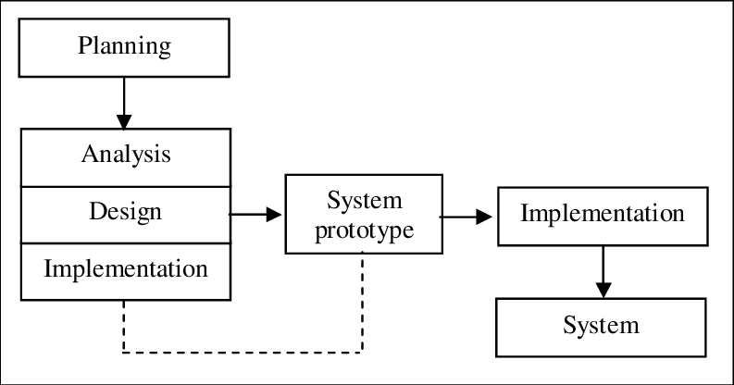
Figure 2. Prototyping Model Software Development Life Cycle
As illustrated in Figure 2, the Prototyping Model follows a structured software development life cycle consisting of four main phases: Planning, the iterative cycle of Analysis, Design, and System Prototype, followed by final Implementation and the resulting operational System.

Planning
During the Planning phase, the researchers established the project goals, determined technical and operational feasibility, and conducted initial coordination with the officials of Barangay Dacutan. The team met with Punong Barangay Hon. Roberto S. Alen and Barangay Secretary Mrs. Ma. Elena Balleza to assess current challenges in managing resident records and issuing certificates. This phase defined the scope, resource requirements, and schedule for developing the web-based management system.

Analysis, Design, and System Prototype (Iterative Prototyping Cycle)
This central phase operates as an interactive and concurrent loop where analysis, design, and prototype construction occur repeatedly to satisfy user needs:

Analysis. The researchers analyzed the specific frontline transactions performed at the barangay hall. This included reviewing paper logbooks, examining the 12 required certificate categories (such as barangay clearances, residency certificates, indigency letters, and first-time jobseeker waivers under RA 11261), studying Katarungang Pambarangay dispute resolution procedures, and identifying vulnerable household criteria for calamity relief distribution.
Design. Detailed blueprints and system architectures were designed. The researchers created entity-relationship models for the MySQL database, modeled system workflows using UML diagrams, prepared user interface wireframes for the public portal and administrative desks, and formatted authentic Philippine Republic A4 certificate templates complete with dual official seals.

System Prototype. An initial working version of BIMS was programmed using PHP Laravel and MySQL. The working prototype was deployed for evaluation by the Punong Barangay and the Barangay Secretary. The users tested key functions, including submitting requests online, approving clearances, and logging blotter incidents. Feedback and suggestions gathered during testing looped directly back into the analysis and design steps (indicated by the dashed feedback arrow in Figure 2), allowing the researchers to refine features and interface layouts until all operational requirements were met.
Implementation

Once the prototype was validated and stabilized, the researchers proceeded with the comprehensive Implementation phase. This stage involved finalizing backend business logic, establishing secure role-based middleware and CSRF defenses, integrating an automated SMTP mailer service for resident request notifications, and performing thorough testing. Functional and security testing were conducted using automated PHPUnit test suites and manual validation. The system was then deployed to a live cloud web server and local workstations at the barangay hall, accompanied by user training for the Barangay Secretary on daily system management.
System

The final outcome of the development life cycle is the completed and fully operational Barangay Information and Management System (BIMS). The deployed system enables 24/7 public online document applications for residents, provides a structured two-tier approval workflow for barangay officials, sends automated email status notices, and centralizes census profiling, legal blotter mediation records, and disaster aid registries into a unified and secure digital platform.

Deployment and Orientation

UML Diagrams

Use Case Diagram
Figure 3 shows the Use Case Diagram of the Barangay Information and Management System, illustrating the three distinct actors (Resident, Barangay Secretary [performing clerical duties], and Punong Barangay) and the specific system actions each can perform.
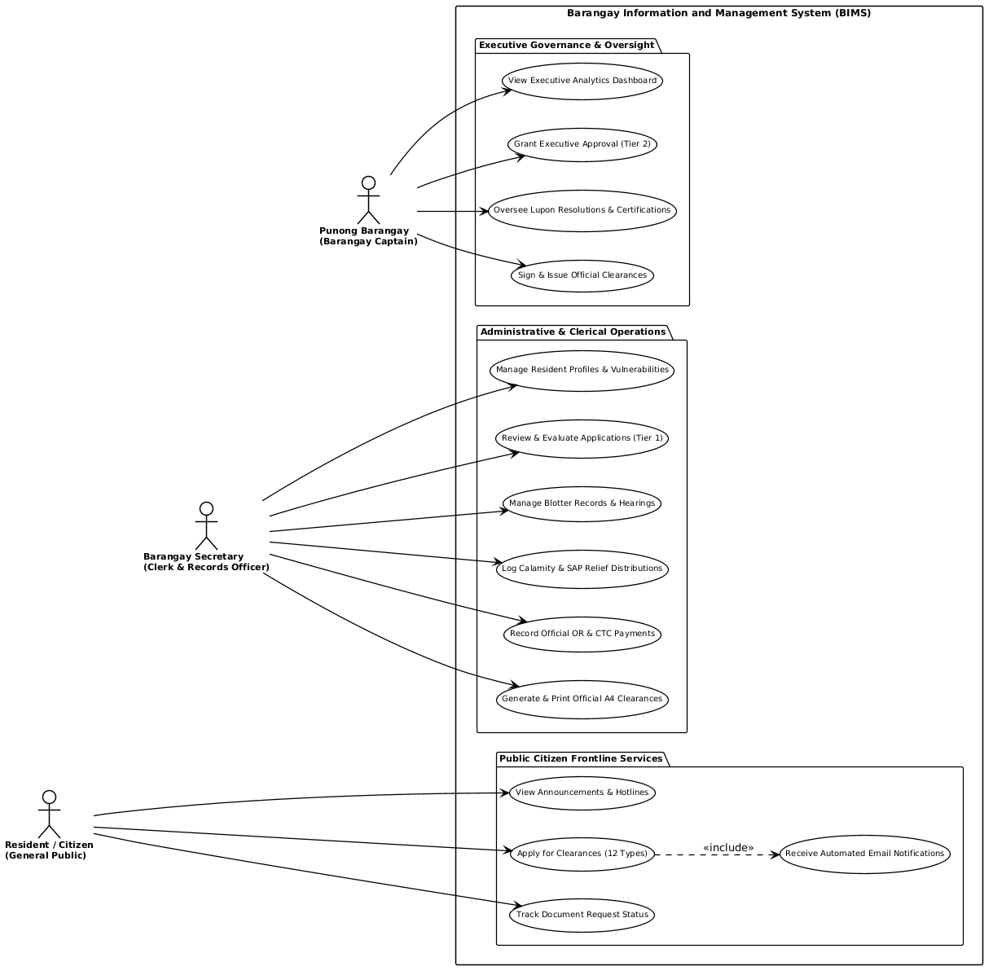
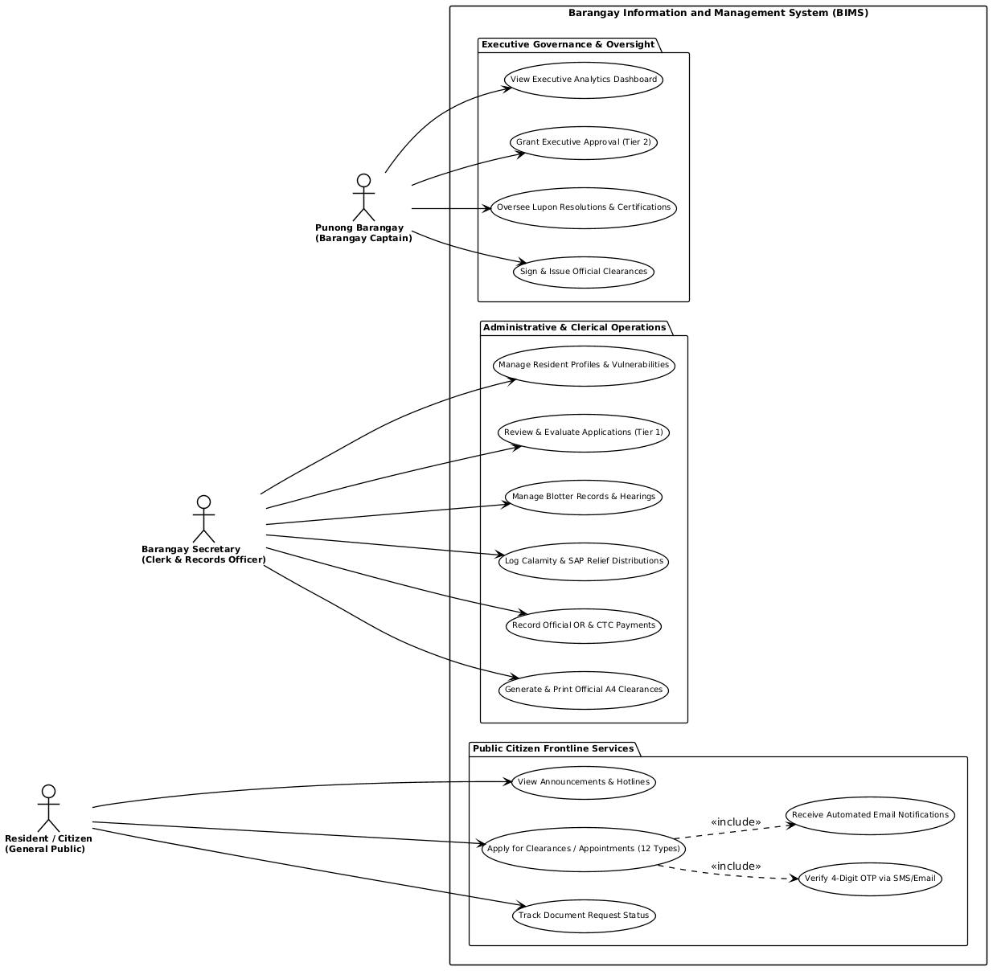
Figure 3. Use Case Diagram of the Barangay Information Management System

Activity Diagram
Figure 4 shows the Activity Diagram illustrating the sequential flow of an online document request and appointment, from initial citizen submission and 4-digit OTP verification to secretary evaluation, captain approval, and final printing.
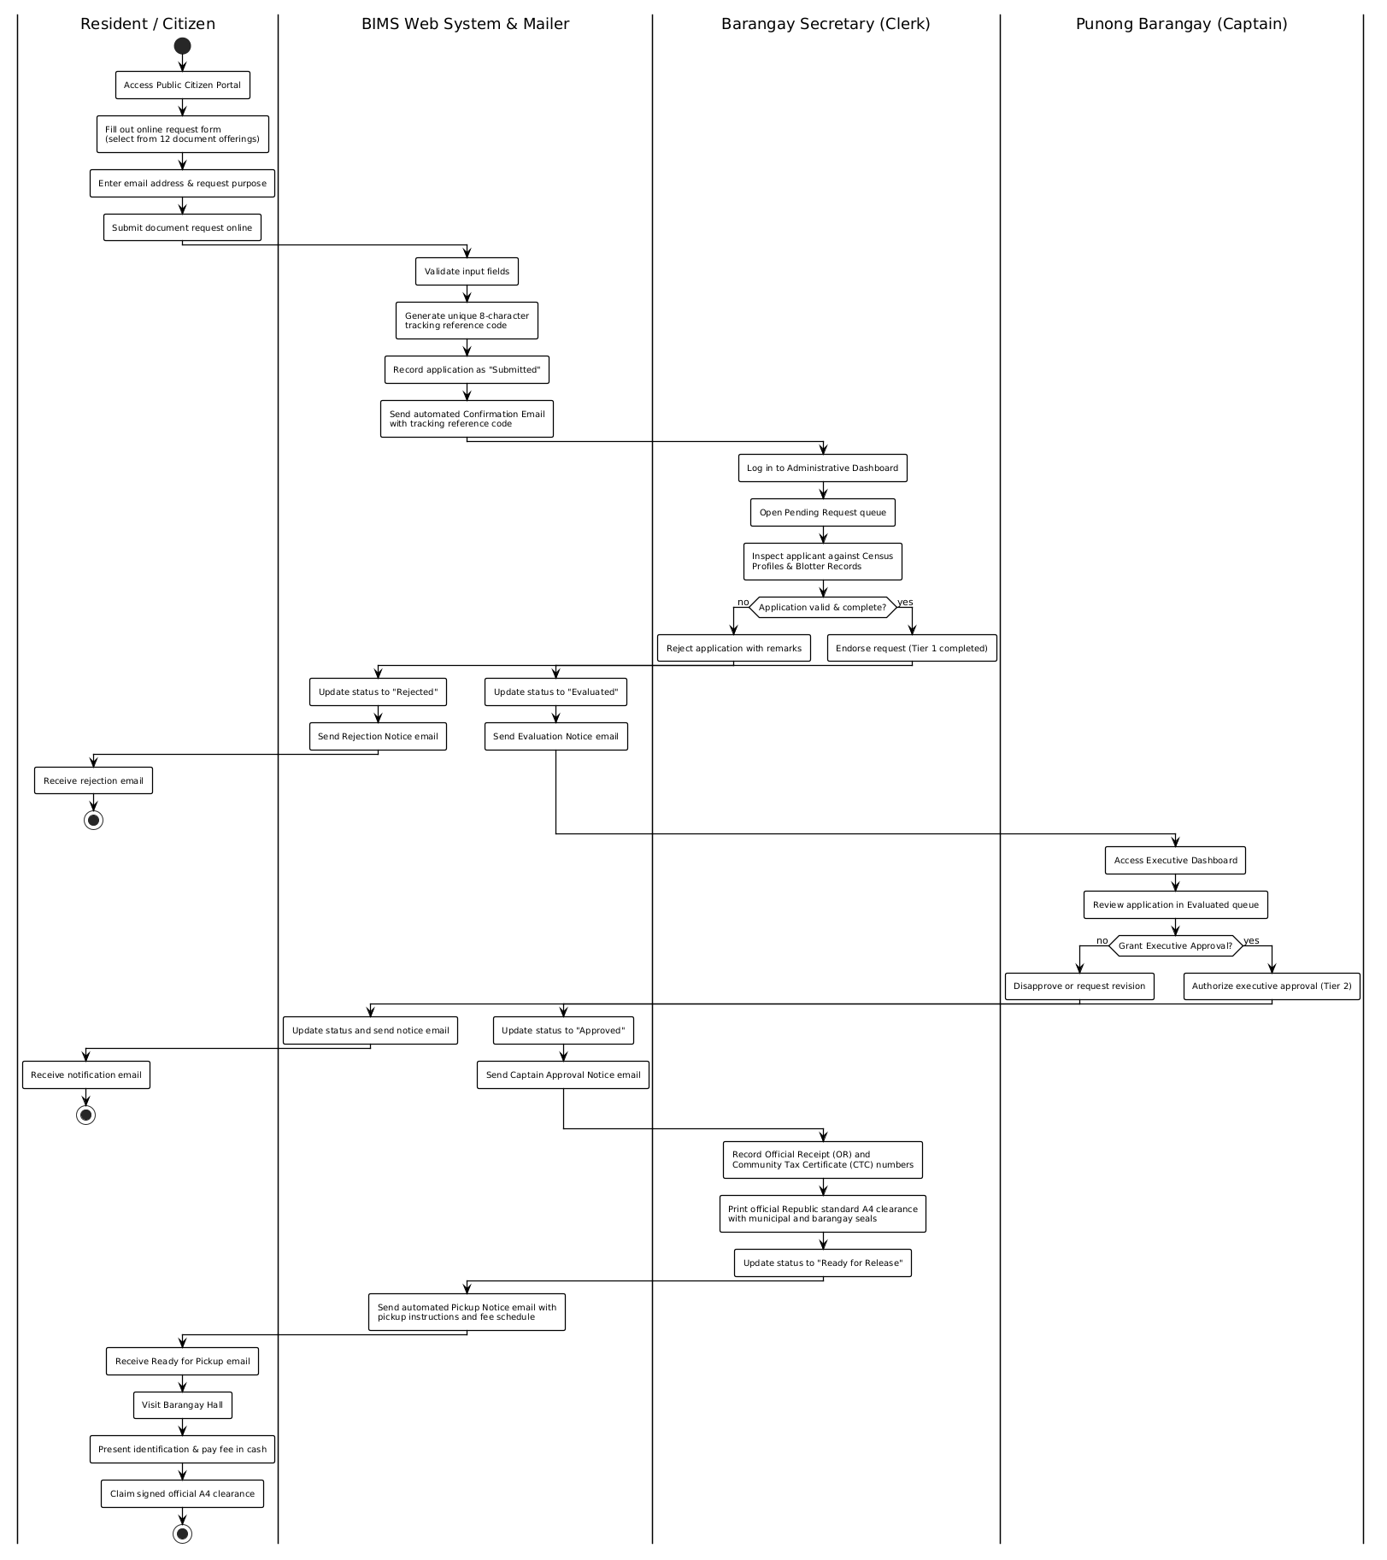
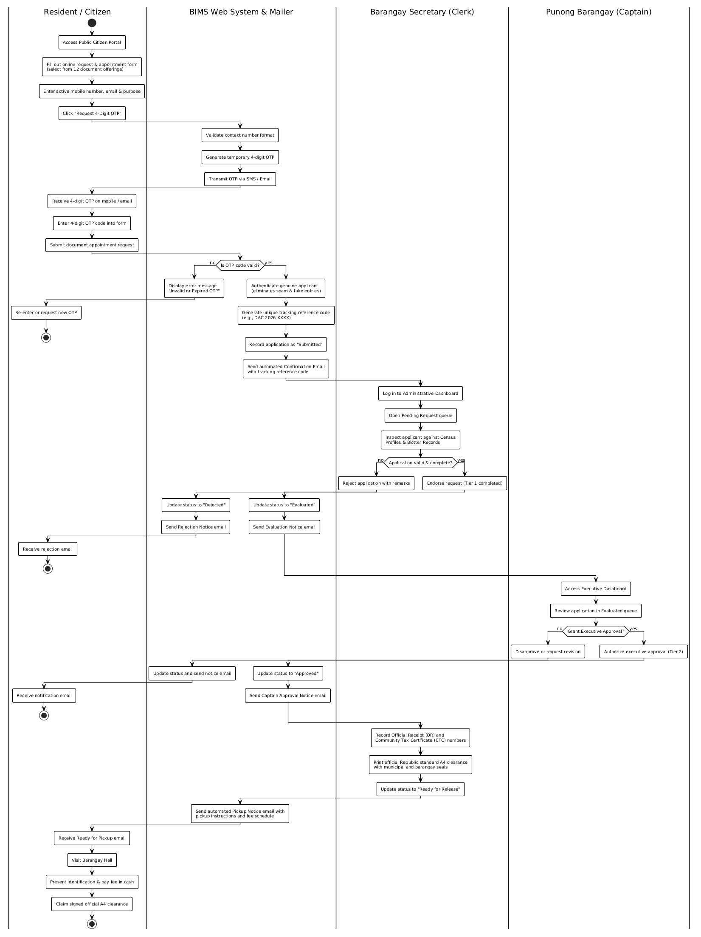
Figure 4. Activity Diagram for Online Clearance Application and Issuance

Class Diagram
Figure 5 shows the Class Diagram depicting the relational database structure, model entities, table attributes, and relationships among users, residents, certificates, blotter records, and aid distributions.
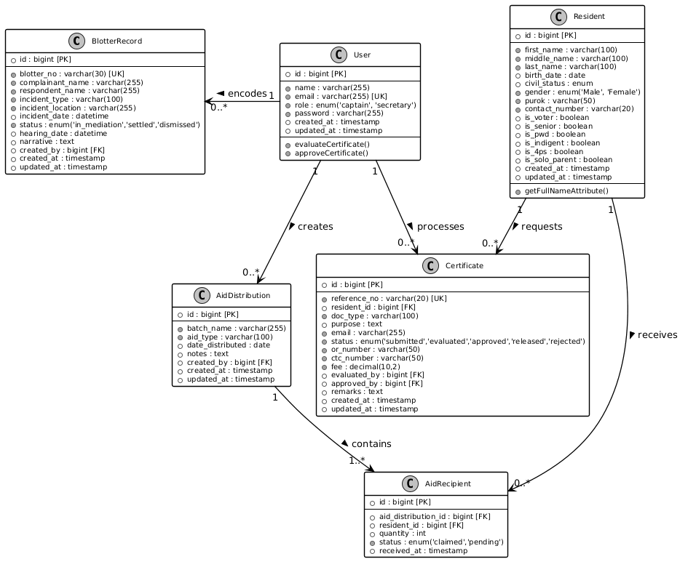

Figure 5. Class Diagram / Database Schema of BIMS

Sequence Diagram
Figure 6 shows the Sequence Diagram illustrating the time-ordered interactions between the Citizen, Web Browser, Laravel Router, Controller, and MySQL Database during document tracking.
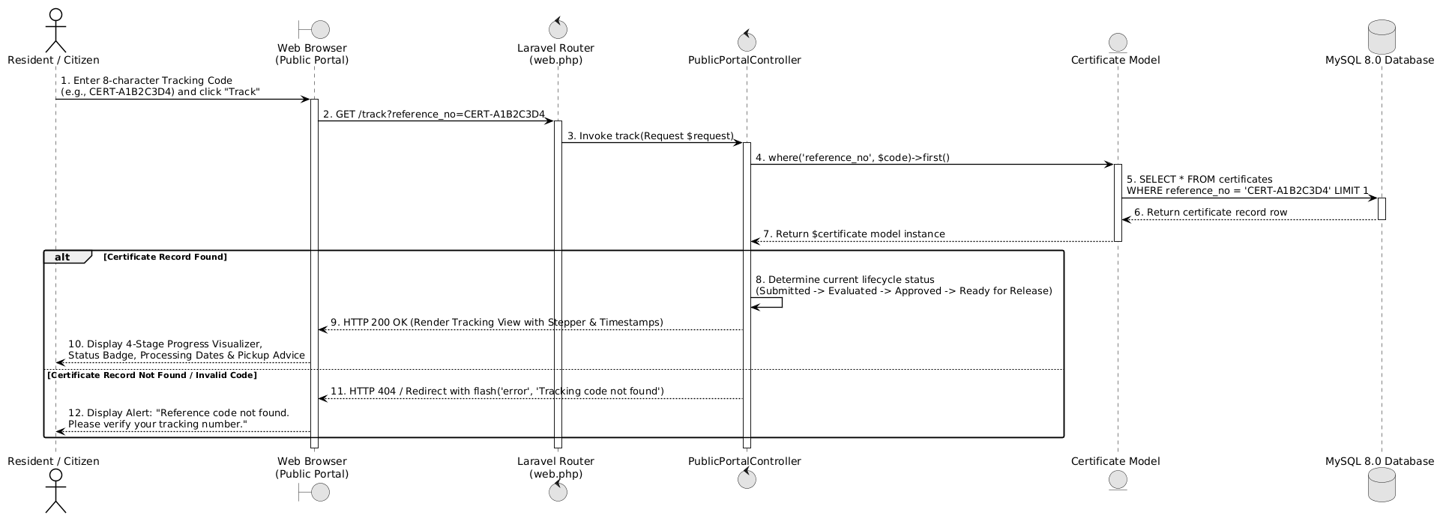
Figure 6. Sequence Diagram for Citizen Document Tracking Flow

System Architecture Diagram
Figure 7 illustrates the physical and network deployment architecture of BIMS, showing how user devices connect over the internet to the live cloud web server and relational database. Public citizens access the responsive web portal using mobile smartphones, laptops, or personal computers, while barangay personnel operate office desktop workstations and network printers at the barangay hall. All internet communications are protected through secure HTTPS encryption (Port 443). The cloud server runs on a Linux (Ubuntu) environment with Nginx/Apache and PHP 8.2, hosting the Laravel 12 application core and an automated SMTP mailer service. The application layer handles request routing, business logic, role-based permissions, and database operations with the MySQL 8.0 relational database.
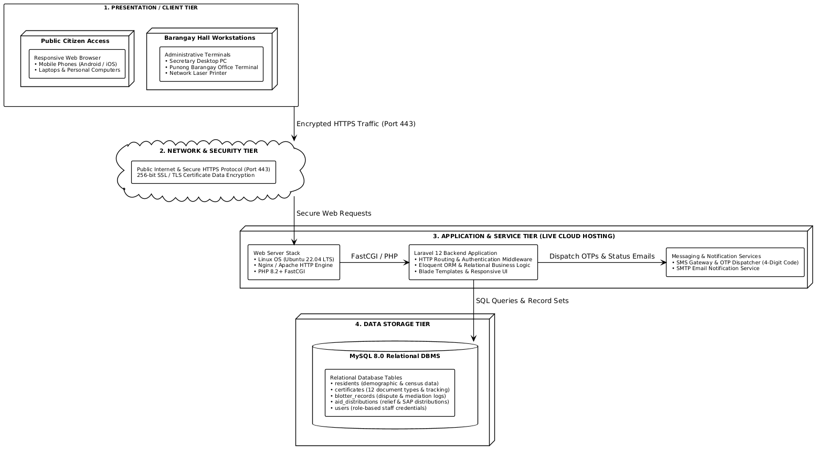
Figure 7. System Architecture Diagram of the BIMS Live Cloud Web Deployment

Requirement Analysis
To ensure reliable and smooth execution, the minimum hardware and software specifications needed to operate BIMS were established.

Hardware Specification
Table 2 shows the hardware specification required to run the system on a host machine or workstation.
Table 2
Hardware Specification for the System
Hardware Component | Minimum Required Specification
Central Processing Unit (CPU) | Intel Core i3 / AMD Ryzen 3 (Dual-Core 2.0 GHz or higher)
System Memory (RAM) | 8 GB DDR4 RAM minimum (16 GB recommended)
Hard Disk Storage | 120 GB Solid State Drive (SSD) with at least 10 GB free space
Display Monitor | 1080p Full HD Display (1920x1080 resolution recommended)
Network Interface | Standard Ethernet LAN (100/1000 Mbps) or Wi-Fi 802.11 b/g/n

Software Specification
Table 3 shows the software specification required to run and maintain the system.
Table 3
Software Specification for the System
Software Component | Required Specification / Tool
Operating System | Microsoft Windows 10 / 11 (64-bit)
Web Server Stack | Live Cloud Web Server (Linux/Apache/Nginx, PHP 8.2+, OpenSSL SSL/TLS Certificate)
Backend Language & Framework | PHP 8.2.12 with Laravel Framework 12.x
Database Management System | MySQL 8.0 Community Server (InnoDB Engine, Port 3306)
Frontend Technologies | HTML5, Tailwind CSS, JavaScript (ES6+), FontAwesome 6
Supported Web Browsers | Google Chrome, Mozilla Firefox, Microsoft Edge (latest versions)

System Evaluation
The quality and performance of the developed Barangay Information and Management System was assessed using an evaluation instrument patterned after the ISO/IEC 25010 Software Product Quality Model. The evaluation covered eight software quality characteristics:
• Functional Suitability: The degree to which the system provides functions that meet the stated operational requirements of Barangay Dacutan.
• Performance Efficiency: The responsiveness, processing speed, and resource utilization of the system under normal operating loads.
• Compatibility: The capability of the system to operate reliably across standard desktop and mobile web browsers and varied internet network connections.
• Usability: How easy it is for barangay staff and citizens to learn, navigate, and operate the system interface.
• Reliability: The consistency of the system in maintaining data accuracy and operating without crashing during transactions.
• Security: The effectiveness of role-based access control, session expiration, and CSRF protection in preventing unauthorized data modification.
• Maintainability: The modularity and clarity of the Laravel MVC codebase for future updates, bug fixes, and feature additions.
• Portability: The ease with which the system can be deployed and transferred to other local government computer setups.
Table 4 shows the Five-Point Likert Scale and corresponding verbal interpretations used to score and evaluate the system.
Table 4
Five-Point Likert Scale and Verbal Interpretation
Scale Rating | Mean Score Range | Verbal Interpretation
5 | 4.21 - 5.00 | Excellent
4 | 3.41 - 4.20 | Very Good
3 | 2.61 - 3.40 | Good
2 | 1.81 - 2.60 | Poor
1 | 1.00 - 1.80 | Very Poor

Data Gathering Instrument
The primary instrument used in gathering evaluation data was a structured survey questionnaire based on the ISO/IEC 25010 Software Quality Model. The questionnaire comprised 24 indicator statements grouped equally under the eight quality characteristics (3 items per characteristic). Each evaluator rated every statement on a scale from 1 (Very Poor) to 5 (Excellent). Space was also provided at the end of the questionnaire for comments and qualitative suggestions.

Respondents of the Study
A total of ten (10) respondents were selected using purposive sampling to evaluate the system. The evaluators were divided into two distinct groups:
1. IT Experts (5 respondents): Information Technology instructors and professional software developers from ISAT U who evaluated technical aspects such as code structure, database normalization, system security, performance efficiency, and maintainability.
2. Domain End-Users (5 respondents): Punong Barangay Hon. Roberto S. Alen, Barangay Secretary Mrs. Ma. Elena Balleza, and community residents from Barangay Dacutan who evaluated functional suitability, user interface ease of use, clearance generation accuracy across the 12 document offerings, and practical community applicability.

Data Analysis Procedure and Statistical Treatment
The quantitative data gathered from the evaluation survey was tabulated and analyzed using basic descriptive statistics. The mean rating for each ISO 25010 characteristic was calculated using the formula: Mean (x̄) = (Σ x) / N, where Σ x is the sum of all individual ratings and N is the total number of evaluators. The computed mean scores were interpreted using the criteria defined in Table 4.
Table 5 presents the summary of evaluation results obtained from the ten evaluators.
Table 5
Summary of ISO 25010 Software Quality Evaluation Results
ISO 25010 Quality Characteristic | Computed Mean (x̄) | Verbal Interpretation
1. Functional Suitability | 4.65 | Excellent
2. Performance Efficiency | 4.55 | Excellent
3. Compatibility | 4.50 | Excellent
4. Usability | 4.60 | Excellent
5. Reliability | 4.50 | Excellent
6. Security | 4.45 | Excellent
7. Maintainability | 4.55 | Excellent
8. Portability | 4.50 | Excellent
Overall Grand Mean | 4.54 | Excellent
As shown in Table 5, all eight software quality characteristics received mean scores well above 4.21, resulting in an overall grand mean of 4.54 with a verbal interpretation of 'Excellent.' Functional Suitability scored the highest (4.65), proving that the core modules (including resident census profiling, online document applications for 12 certificate types, and standard A4 clearance printing) accurately satisfy the operational requirements of Barangay Dacutan.

